Chronicles of St. Patrick’s High School- December 2025

PRINCIPAL’S MESSAGE

“True education shines when intellect, talent, and character walk hand in hand towards excellence.”

It gives me immense pride to share that our students have once again brought laurels to the institution by excelling in academics, sports, and a wide range of co‑curricular pursuits. This year, 42 of our young athletes qualified to represent the school at the national level in the CISCE Sports Competition, a remarkable achievement that reflects their dedication, discipline, and perseverance. Equally commendable are the academic milestones reached by our students, whose consistent performance underscores the values of hard work and intellectual curiosity.
Throughout the year, our students also engaged in numerous co‑curricular activities — from cultural performances and literary events to debates and creative arts — each fostering confidence, teamwork, and holistic growth. Their creativity and imagination have found vibrant expression in classrooms, on stage, and in the pages of this very emagazine, reminding us that education is not only about achievement but also about innovation and self‑expression.
Our 114th Annual Day Celebration, on 15 November 2025, graced by the esteemed presence of Shri Jishnu Dev Varma, Hon’ble Governor of Telangana as the Chief Guest, was a fitting occasion to honour these accomplishments. The event stood as a celebration of holistic excellence — academic, cultural, and athletic — reaffirming our commitment to nurturing well‑rounded individuals.
As we look ahead to a new calendar as well as academic year, may these milestones inspire every student to dream bigger, strive harder, and uphold the spirit of our school in all their endeavours.

Fr. A. Elango SJ
Principal

FROM THE EDITOR’S DESK

Kindness, Courage, and New Beginnings
Every new year opens a fresh page in the story of our lives. As we stand at the threshold of 2025, let us pause to reflect on our journey—its triumphs and trials, its lessons and memories—and carry forward the spirit of hope into the year ahead.
Hope begins at home. Our families are our most precious treasures. Let us be their eyes to understand, their ears to listen, and their voices in conversations that heal. May we resolve to spend quality time with our loved ones, becoming their shield in moments of struggle and their armour in times of need.
In our homes, let us choose compassion over blame, kindness over humiliation, and action over procrastination. Together, we can be miracle makers—lifting one another and showing what true humanity looks like.
The year 2025 has brought challenges and changes, but also resilience and growth. It has taught us to embrace opportunities, respect priorities, and set examples not only for ourselves but for those who look up to us. In a blink, the year has passed, leaving behind memories to cherish and lessons to strengthen us.
As we welcome the new year, let us carry forward kindness, courage, and the will to embrace new beginnings. Our families, friends, and school community are the foundation of our strength, and together we can create miracles through compassion and unity. May the year ahead be a journey of hope, growth, and brighter tomorrows—where each of us shines not just for ourselves, but for those who look to us for inspiration.

Mrs Nancy Marian
Chief Editor



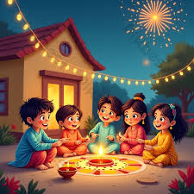

My Favourite Game: Cricket
I like to play cricket. It is a fun game. I play cricket with my friends. I love to bat first and I hit the ball and run. I play with my family as well. We play together and have lots of fun. Cricket is my favourite game. I love cricket.
Alhan Ahmed Khan
I - G

Happy Diwali
Diwali is a festival of lights. My favourite festival is Diwali. This year we celebrated Diwali with my family members at my grandfather’s home on 21st October 2025. We performed Pooja and ate sweets. We wore new clothes and burned many crackers.
Adhvika Kota
1 - A

Healthy Habits
Healthy habits help us to stay strong and healthy. We learn about healthy habits at school. We also learn about hygiene and cleanliness. We keep our classrooms and surroundings clean. We play games on the playground to stay fit and active.
Alyan Ahmed Khan
II - D

MY TRIP TO TADOBA
Tadoba is a beautiful jungle in Maharashtra. It is a tiger reserve located at Chandrapur on the way to Nagpur. My family and I travelled by the newly launched Vande Bharat train. This place has many animals like wild boars, leopards, monkeys, black bucks, spotted deer and peacocks too. It was a four-hour jungle safari. I was amazed when I happened to see two tigers. One was a male tiger, called Bali and the other a female, called Chandha. They were playing, but to me their play was scary. While returning, we bought a few things as a remembrance of this place. It was an adventurous trip, and I enjoyed it very much.
Raymond Jordan
II - F

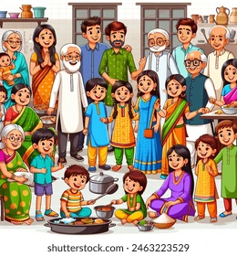

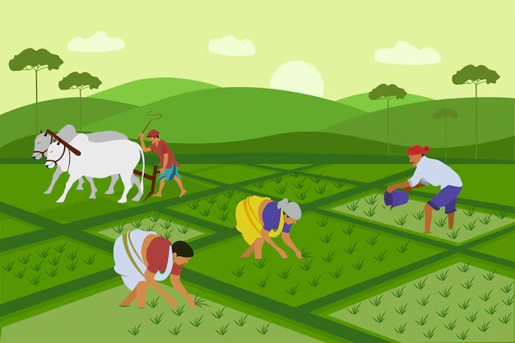

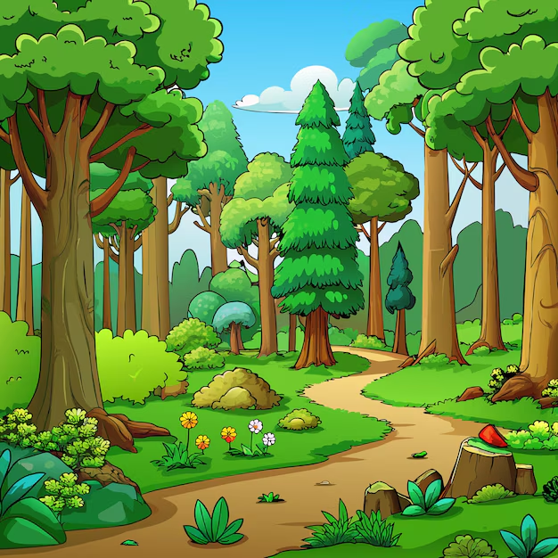
My Big Joint Family
It’s sad to see, it’s no longer preferred, a joint family is the only family I will always prefer. As my day starts with greeting my elders, it surely ends with fighting and laughing together with my brothers and sisters. Uncles and Aunts are just one call away if you need someone to save you from a very bad day.
We may face many trials, but together we stand in every situation. “My Family is where life begins and love never ends. I love my big joint family very much”
Aarav Puneriya
II - E

Farmers
India is an agricultural country. A farmer is an important person in our country. He is the heart of our society. He gets up early in the morning, takes his plough and goes to his fields. He works hard throughout the day. Farmers grow crops and supply food. We get all the fresh vegetables and fruits from them. Farmers help our country grow economically.
Nowadays, farmers use modern tools and techniques to produce more agricultural products. Farmers face problems like drought and floods. If the crops fail, his life becomes miserable. We must respect all farmers and pray for them. Don’t waste food! Jai jawan jai kisan!
Haanvi Rathnam
III - A

Trees
A tree is a very important part of nature. Trees give us fresh air to breathe and keep the environment clean. They also give us fruits, flowers, wood, and shade. Birds build their nests in trees.
Trees help to bring rain and keep the earth cool. Without trees, life on earth would be very difficult. We should take care of trees and plant more trees to make our world green and beautiful.
Nehemya
III - B

My Trip to Vishakapatnam
Recently, I visited Vishakapatnam. I had a great time visiting many places, which left us astonished. Firstly, we booked a room in a hotel for three days. We had a wonderful stay there. Then we visited places such as Kailasagiri, the beaches, Aircraft and Submarine Museums, Mini Tirupati – Simhachalam. Then we took a train to Araku Valley, where we visited the coffee plantation, the chocolate factory and the Araku Tribal Museum. We saw the mesmerising beauty of the hills and their greenery. Then we took a train to Borra Caves and had an unforgettable experience there. We created many memories. This is the most memorable journey I have ever had.
O. Vishwanth
IV - A

My Crazy Car
I love toys, but my mot favourite toy is my car. Its name is Lykan Hyper Sports car. It is shiny black and looks super cool. The car is made of metal. It has glass windows, front lights, and back lights. The lights are red and white.
The best part is that the doors can open! My parents gave me this car as a gift, and I was so happy. I like to race it across the floor. When I play, I imagine it is a real car driving fast on the road.
My Lykan Hyper Sports car is the best toy ever!
John Joy
III - C

My Trip to Mysore
During my last vacation, I visited Mysore, one of the most beautiful cities in Karnataka. It was an unforgettable trip filled with history, culture and fun! We started our journey early in the morning from Bangalore. The drive to Mysore was very pleasant with green fields and small hills along the way. When we reached Mysore, the first thing that caught my eye was how clean and peaceful the city was!
Our first stop was the famous Mysore Palace. Mysore Palace was built by Maharaja Krishnaraja Wadeyar IV. It looked grand and majestic, especially with its shiny golden domes. Inside the palace, we saw beautiful paintings, royal furniture and antique items used by the kings. In the evening, the palace was lit up with thousands of lights- it was like a dream.
Next, we visited the Chamundi Hills, where we climbed many steps to reach the Chamundeshwari Temple. From the top, we could see the entire city of Mysore. We also saw the huge Nandi statue, carved out of a single rock. Later, we went to the Mysore Zoo. We also tasted the famous Mysore Pak, a delicious sweet dish.
My trip to Mysore taught me about our country’s rich history and culture. It was both an educational and enjoyable trip.
K Nishitha Devi
IV - A

Shirdi Sai Baba
Shirdi Sai Baba is a wonderful teacher and a God to his devotees. His most important teachings are "Shraddha" ("faith"), love, compassion, charity, contentment, peace, worship of God, and the guru. It is believed that he has the power to remove the difficulties of his devotees.
Sai Baba is considered an incarnation of Shiva and Dattatreya. He mainly emphasized two things: "Shraddha" and "Saburi" ("patience"). Both of these are important teachings of the Hindu tradition. He emphasised on living a life guided by love, forgiveness, contentment, and inner peace.
B. Kritika
V - E

Slingshot Terror in the Theatre
Once upon a time, in the big city of Mumbai, lived a boy named George. He studied in a school named A.V.P. Vidyamandir High School. He was an orphan and was adopted by the headmaster. He was a very mischievous boy, but had many friends. One day, his teacher announced a field trip to the theatre to watch a movie called The Karate Kid. The students sat on their chairs and popcorn was brought in by the waiter for everyone, but George did not accept it. George had brought a slingshot and a streamlined pebble. As the movie was halfway through, he took the pebble and shot it at a girl named Samara. The pebble overturned the popcorn box and directly hit Samara’s eye. Samara squealed in agony and was taken to a hospital. She was left temporarily blind, and George lost all his friends. He then realized the importance of discipline.
Moral: Be disciplined.
Elroi Jomon
VI - H

The Cost of Cheating
When I was in Class II, I was not feeling well during my exams, and I happened to prepare for the wrong subject. I prepared for Social Studies, while I had to prepare for Science. When I got the question paper, my mind went blank. I became anxious and nervous. In that moment of weakness, I copied the answers from my friend’s paper without understanding what I was writing. I handed the paper to the invigilator with mixed feelings of relief and guilt.
After evaluation, when we got our answer scripts, I was shocked to see such wonderful marks. I was one of the class toppers. Everybody praised me, while I felt guilty and unhappy deep down in my heart, because those marks were not mine. I finally gathered the courage and confessed the truth to my Science teacher. My teacher was surprised, but proud of my honesty. She deducted my marks and told me that true success comes from hard work and integrity.
This experience taught me a valuable lesson: “Cheating might seem an easy way out, but is not worth the risk.” From then onwards, I started focusing on studying hard and being honest. This really helped me to become the class topper since class III. I am very happy that to date, I have been able to secure 1st rank in my class.
Shaik Ameen Peer
V - E

My Favourite Place
My favourite place is my village. It is located in East Godavari, Rajahmundry. My grandparents live there. It is where I enjoy the most, as it is a peaceful place. There is a huge backyard with a stream running nearby. There are different kinds of trees like mango, custard apple, coconut and even mint. They even have flower-bearing trees like jasmine, hibiscus rose, and sunflower.
In the mornings, we wake up and go to the backyard to enjoy the peaceful surroundings. We play different kinds of games and spend the whole day enjoying the warm sun, and listening to the chirping of birds, the sound of the flowing water, moving leaves. The cool breeze makes me feel refreshed.
I had a wonderful and adventurous time. I took many pictures, played with my cousins, and had a picnic party (lunch) with my family members. The days I spent there are like a dream.
Polumati Joy Aaradhya
VII - D

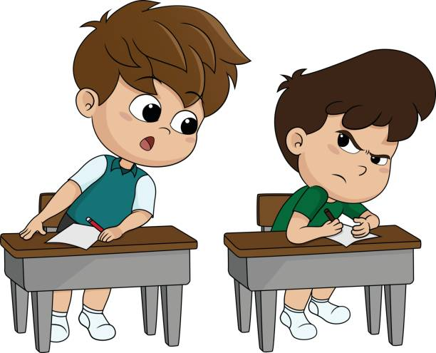

What will I do if a Dracula or a werewolf is my next-door neighbour?
Aawoo… Aawoo [wolf’s howl] When I heard this, I went into my neighbour’s house with a flashlight, as the lights were out and it was raining in the dead of the night. As soon as I entered the house, I saw a shadow moving fast. I was shivering thinking to myself why did I even enter. After that I also saw some scratches on the wall, those of a werewolf.
A few months ago, my new neighbour moved into town. No one was suspicious about him except me. I saw that he was limping, which many members of the town thought that he had some injury but didn't see the blood stains on his pants which I had seen. It turns out that, it was Mr. Remus Lupin, a professor of Hogwarts School of Witchcraft and Wizardry. You might think how I got to know this, because I was also a part of that school.
A few weeks later this incident happened. I was standing with my magic wand in my pocket and a werewolf jumped on me. I took out my wand used the curse “Stupefy!” seconds later the werewolf flew across the room. I let out a sigh of relief and went back to my house. The next morning, Professor Lupin burst into my room and with his wand on my neck, said, “Dare you do that again and I will kill you.” I got up, gulped nervously and secretly held my wand on my back and said, “I am not afraid of you Remus!” After that he said, “I have had enough and now I will end your life!” After that he used the curse “Avada Kedavra” and tried to kill me as that curse is used to kill people. I held out my wand and said, “Protego Maxima” which protects one from the curses in the world. The curse flew back at him. He was going to use the “Protego” spell but his wand fell out of his hand. Then I used the “Alarte Incomtatem” spell to stop it.
He knelt before me and said, “I thought of killing you but you saved me.” I was very happy from then we became the of best friends. I asked him about the werewolf and he said, “Whenever there is a full moon, I turn into a werewolf. Remus eventually died in the battle of Hogwarts with Voldemort and I am narrating the story to you.
Madanu Bala Anthony Nadisu
VIII - D

Wonders of the Outback: My Perfect Getaway
My favourite place in the whole world is my uncle’s house. He lives in Singapore and also has a house in Australia, where I prefer to stay during vacations. I like that place because of its neatness, greenery, and the fun I have there.
He lives with his kids, my cousins Raphael and Angel. They are both older to me but are always kind to me whenever I visit them. I also made some friends in Australia who were super nice once they learned that I came from India.
My uncle often takes me to different places. I love to go with him to the cricket stadiums. The loud cheers of the crowd, the sounds of clapping, shouting, and the excitement of the matches thrills me. Sometimes we also see a few celebrities living nearby.
I even met the greatest left-arm pacer in the history of Australian cricket, Mitchell Starc. He was a kind-hearted person, and his soft nature towards people was totally different from his aggression on the cricket ground.
The sights of greenery, the laughter of my cousins, and the happy moments I spend there always brings me joy. Truly, this is my favourite place.
Anthony Chris
VII - G



The Day I Became a Hero in My Own Eyes
The door creaked open frightening me. I turned around and I saw it. Seventeen days earlier I was just an ordinary, simple human. A 9-to-5 job, average salary. Our neighbours, the Carters had bought a new home. The day after which they shifted and a new neighbour arrived. His name was Roderick. He was a kind and gentle person. Everybody in the neighbourhood liked him for his kind gentle and helpful personality. But the next day, two children went missing, and they were still not found.
Day by day, children kept vanishing. Rumours spread that Roderick was the kidnapper but many did not agree. One cold night, I went to bring milk from the grocery store. While returning, I saw Roderick with a small girl. He was walking with her. At first, I just thought that he was talking to her and left it at that.
When I woke up, I found out that the little girl was missing. It was the first time I suspected Roderick. The next week, while coming back from work, I saw Roderick with another child and the next day the child went missing. Now I was confident that Roderick was the kidnapper. The next day, I wanted to get to the root of the problem. Hence, I took a day off from work and decided to follow him.
I followed his car for a few hours. At night, he parked his car and went to a small child, gave him a lollipop and made him sit in his car. He took the child to his house, I followed behind. I tried to enter the house through a window but it was locked. I somehow managed to enter through the attic by climbing onto to the roof and entering through the window.
I went downstairs and saw the horrifying scene. Roderick in the form of a Dracula. I quickly ran and hid behind the door. The door creaked and I was frightened. I jumped down from the window. The next thing I remember is waking up in a hospital and found out that Roderick had left the neighbourhood. I was happy to hear the good news.
P Shreyan
VIII - G

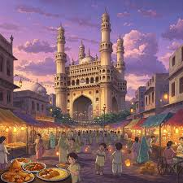
Hyderabad - The Pearl City
Hyderabad stands proud and tall,
By it the Musi flows, it welcomes all.
Tank bund stays calm and wide,
With Necklace Road shining all night.

The tall white Legislative Building is so bright,
Glows like a palace in the night.
Charminar shines in the Old City’s light,
Four grand pillars glowing bright.

Golconda tells stories of old,
Of Kings, Queens, diamonds and gold.
Nizams ruled with royal grace,
Leaving palaces grand all over the place.

Birla Mandir and Mecca Masjid shine,
Giving the city a cultural design.
Bustling bazaars full of colour and sound,
With pearls and perfumes all around.

Hi-Tech city touches the sky,
Where dreams grow strong and fly high.
Nature, beauty and history all stay,
Making Hyderabad special every day.

Aryan Vitthal Arjun
IX - C

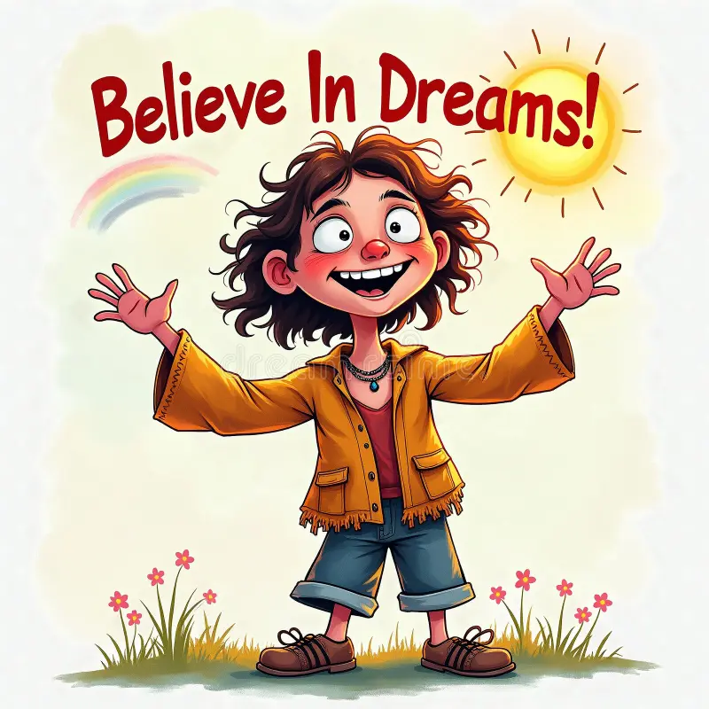
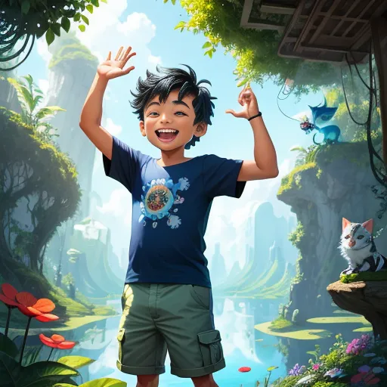
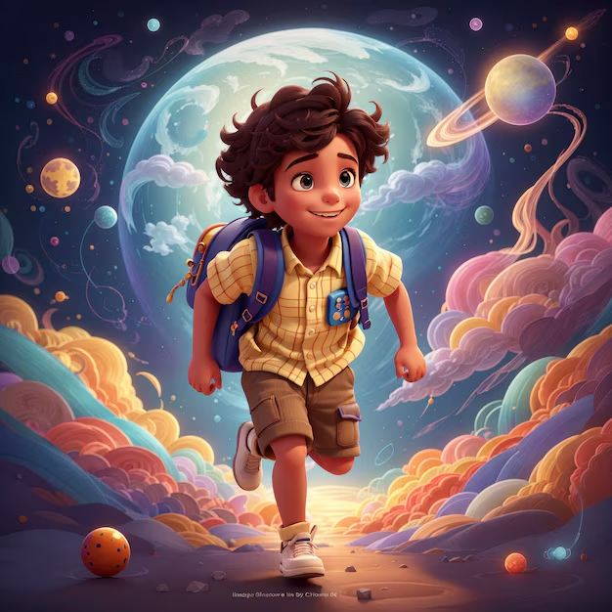
The Builders of Destiny
Many wait through golden years, for magic winds to calm their fears.
They dream of knocks upon the door, of fortune spilling on the floor.
They hope success will gently land, Without the toil, without the hand.
But life rewards the ones who strive, who chase the dawn, who feel alive.
They blame the stars when plans go wrong, and sing of luck in a wistful song.
Yet truth is carved in sweat and pain - Success is earned, not caught like rain.
Luck may whisper once or twice, A fleeting gift, a roll of dice.
But hard work builds with steady pace, a future time cannot erase.
To grow in strength, you train each day. Not wishing for ease to light your way.
Luck is rain in desert air - a fleeting drop, a whispered prayer.
But dig a well with a calloused hand, and water flows at your command.
When you choose work, you choose your fate, you shape your path, you own your state.
You steer the ship; you set the sail. You write the story, not the tale.
And soon you see, with clearer sight, that success is not chance - it's a right.
The ones you praise, the stars you see, aren't chosen by some lottery.
They rose while others stayed in bed, they fought through doubt and pushed ahead.
They failed, they fell, they rose once more. They knocked on every silent door.
You see the shine, not all they gave - The nights they wept, the strength they braved.
So, build your dream with grit and grace. Let effort be your guiding place.
For luck may pass, but work will stay - And carve your legacy each day.
Cheera Brindan
IX - B


Into the Unknown: My Space Adventure
It was a bright day when we heard an announcement that our school was going on a trip to space. When I heard this news, my excitement knew no bounds. As soon as I went home, I started packing my things for the trip. The amount to be paid was rupees 50,000/- each. The next day we started with an astronaut, who was telling us about space. He asked questions like which planet do you want to visit first? I wanted to visit Saturn because I wanted to see whether there was a difference between Earth and Saturn. When I reached, the beauty of the planet could not be described in words as a planet was far away from the sun, the water was also in the frozen form. The next moment when I kept my foot on the land, I was shocked because there was no difference. Then a funny thing happened, my friend slipped down and she wasn't crying but instead she was laughing as she had inhaled laughing gas and we both explored beautiful the places on Saturn together. I could not believe that there were only two people on the whole planet. My friend was thirsty that she had to drink the water, after drinking the water my friend said that the water tasted like mineral water on earth and when we looked in the water, we saw some cute and some dangerous animals in the water. One fish jumped and fell on the ground. The first one was of ash colour. We had no time left and had to leave. Later we shared our experiences. We had the best experience in the whole group.
Syeda Sama Arzeena
IX- E

Beyond Earth: My Voyage into Space
It was a pleasant morning, the beaming rays of the early sun piercing through the windows in a bedroom of a lavish bungalow, announcing the morning to a young boy, Leo, who was the son of the richest man in Delhi. Leo was as lazy as a sloth, woke up only when the clock jolted him from sleep. Oh no! It is 8:30 already. He rushed to the bathroom, cleaned himself and ran into the kitchen where a mouth-watering meal was waiting for him. Unfortunately, as he was running late, he could only shove a piece of bread and rush to school to another boring, regular day, or was it?
Leo was quite an ambitious kid with big dreams to achieve. He was an all-rounder, basically good at everything. As the day progressed to lunch break, the principal made an emergency announcement stating to display the live news in the class, as a channel was opened. There was a breaking news that flashed across the screens in the classrooms, “The world is about to end.” The scientists found out that the earth’s core was collapsing and the whole planet would implode in just ten years. The whole class, the school and even the whole world was thrown into chaos. Everyone was shocked, some were scared and others including Leo were devastated. “I have a long life to live.” murmured Leo. All his dreams, ambitions and hopes were all crushed in an instant.
The school was dismissed and all the children were sent home. Leo was still pondering only on the thought of how to stay alive. One day, as humanity was trying to figure out a way to prevent human extinction, a company came up with a program to send a select few children to Mars. Upon hearing the news, Leo instantly applied. His skills and his intellect were considered and Leo was selected. The whole of humanity put in all that they had into sending all these kids to Mars and to rebuild the whole human society. The change that was brought about was cruel and unthinkable but for the good of the whole humanity they had to change.
Did Leo and the others save the Human Race? What is your take on the question?
Mevin Joseph Sebi
X - D


Examination Does Not Decide a Student’s Future
I am completely against the idea that examinations decide a student’s future. Many people still believe that a child’s future depends entirely on exam results—but I strongly disagree.
If that were true, how did so many great people reach the top of the world without relying on exam scores? Take my inspiration, Sachin Tendulkar—he didn’t excel academically, yet he became one of the greatest cricketers in history. Does that mean I should stop studying? No. But it does mean that exams alone cannot define who we are or what we can achieve.
Some students already have the mindset that they won’t do well in exams, and so they stop trying. But that is where they truly lose—to themselves. They say, “Why should a piece of paper decide my future?” And they are right to question it. There are countless people who work hard and succeed in life without having strong educational backgrounds.
Just look around us—even in India, or to be precise, in Hyderabad. Do you think the daily workers at Clock Tower wrote exams to earn their living? No. The truth is, there are more illiterate people in India than literate ones, and yet many of them survive and support their families through hard work.
In our country, examinations are often seen as sources of stress, anxiety, and fear. If exams truly decided everyone’s future, then everyone who studied hard and scored high marks would be millionaires today. But that’s not the case.
So, I urge everyone—parents, teachers, and students—to think: Can a single sheet of paper truly decide a child’s destiny? The answer is no. Because what if a student fails an exam? Does that mean all their hard work and dedication goes waste? Certainly not!
To all parents—please support your children through their hard times. Be their pillar of strength and believe in their potential. And to all my friends—don’t be demotivated by what others say. Believe in yourself.
Remember the story of a boy from Portugal—Cristiano Ronaldo. He lost his father at a young age, was expelled from school for being poor, and even worked cleaning streets. Yet, he rose to become one of the greatest footballers in history.
So, don’t let exams define you. Let your determination, hard work, and belief shape your future.
Clifford Emmanuel Micheal
IX - E

Where Simplicity Lives: My Village Experience
It was a pleasant Sunday morning; my father and I were alone at home. We decided to go to a village for a day out as my father claimed life in a village was very peaceful. I thought why not experience it myself.
We went to a village named Dhana, quite far from the city. I was shocked to see hardly any vehicles in the village. Sunday did not look like a Sunday in that village unlike in cities. People were busy with their work. The biggest and the most modern shop I saw in the village was a grocery store, which would hardly be around four hundred square feet in area. It was my first visit to such a remote and backward village, hence, everything came as a surprise to me.
People of the village used cycles and bullock carts, most of them preferred to walk, a few of them had two wheelers. As a city dweller, I felt that life was so difficult in a village. There was a small health clinic and a local police station in the village. People lived in kutcha houses made of mud, wood and tiled roofs. Brick houses were a very rare sight.
The village was small, so people could communicate with each other easily and there was no need of mobile phones either. I saw most of the people working in their fields and the rest of them in small shops.
My father knew someone in that village who came to the city at times to sell his goods especially during the festival season. We went to meet him and I enquired about the daily routine of the villagers. He told us that life in the village was very simple. People got up very early in the morning, performed their rituals and prayers, had breakfast and left early to work on their farms. There was a small government school where children went to study.
Women did the household chores and went out to collect sticks and reeds for cooking or to draw water from the wells. The men went to work. I noticed the man we were talking to was quite fit. I asked him the secret of his fitness, he told me that all the villagers ate unadulterated and pure food, unlike what we ate in the cities. Chapatis, rice and vegetables were their fixed diet. The second reason he said was their hard work. The villagers were used to lifting heavy loads as part of their job.
There were hardly many families who had a television at home. Children played outdoor games in the evenings and when their parents returned from work, they had a hearty meal together and spent their time talking to each other.
After listening to all this, I felt village life was the best where nobody had any grudges against the other, sat together, laughed and talked to their loved ones without any worry. People had less money but a lot of peace of mind unlike people of the city who have a lot of money but are busy with their own work and have no time for their families. I felt that surviving without technology is possible in the world today and it makes living more beautiful. A Sunday well spent as it was my best experience so far.
Murtaza Carori
XI - AEC

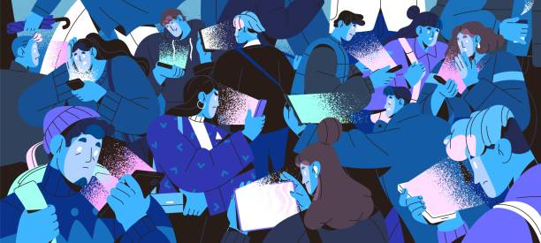

Alone Together: The Digital Dilemma
Does technology make us alone? A simple answer would be yes. We humans as a civilization have evolved a lot in a short period that we are on this Earth. Though humans are a social species, now-a-days a lot of young people distance themselves from each other. I would like to tell you about a guy who is in the prime of youth as an example.
Introducing Adam, a 16-year-old boy who lived in an urban city. Being tech savvy was nothing out of the ordinary here. I mean in today's society it is mandatory and Adam knew this all along. All were quite in tune with their gadgets and they are almost always on their phone using them to communicate instead of going to them personally. Adam was ten years old when Corona virus hit the world. This is where it all started, with nothing else to do Adam got on his computer and started learning how to use it to its full extent.
As he got the hang of it, he started ignoring other sources of entertainment. His parents pleaded and asked him to talk to people instead, but unfortunately due to the lock down and not being allowed to go out for one and a half years, his social skills had become rough and he was not comfortable talking about his interests as people saw him as a nerd wherever he went. This made Adam and what many may call an introvert. He really wanted to talk but just couldn't out of fear. So instead of coming face to face with people he decided he would talk to them online using social media. After a week of social media, he did not want to stop using it.
Social media is easy to use and convenient. You don't even have to get down from your bed to talk to people. All you have to do pick up your phone and text them that you want to see them and you just do a video call. This encouraged Adam and many others of his age to stay at home locked in their own rooms seeing the real world through the virtual screen. This was Adam’s experience but we all know too well that society as a whole is headed to a lonely future, now, more than ever. With stay-at-home jobs, online delivery, social media and online schooling, we humans have lesser reasons to venture out of the house. Not all hope is lost. However, as this situation is mostly among teens to be Anti-Social.
There is however one more thing, online bullying! Online bullying makes people depressed and makes them feel like the word is going to hate them so they often stay indoors and do not come out unless absolutely necessary.
All this proves that Technology makes us anti-social and alone.
Arugula Yuvraj
XI - MPC

Exam Stress – How to Beat It!
Books and papers spread around the room, sleepless nights, dull faces and tried students are a common sight during the exams. Most of us go through this temporary phase of exam stress or exam fever. Exam stress is one of the most difficult things a student faces, leaving the actual exam difficulty far behind.
Exam stress is caused by constant delusions of failing, being taunted and punished. Many students procrastinate studying till the night before the exam leaving them scared on how they are going to complete the syllabus in the span of a single night. Other reasons can be feeling overconfident even after ample preparation, comparing one’s own progress with fellow peers and most importantly the results.
This mental torment has adverse effects on both physical and mental aspects of the body. Physical manifestations like eye bags, dark circles under the eye, headache, fever, hair loss are all clear signs of exam stress and cramming. More than physiological exploitation it is mental health that declines. Exam stress makes one less confident, ‘not enough’ ‘useless’ and ‘inferior’ these feelings sometimes make students take to negative thoughts like suicidal mindset, isolation and delinquency like drug and alcohol addiction.
Exam stress can be dealt with following simple steps like not procrastinating, studying and revising regularly and consistently. Continuous stretches of studying make students feel lethargic and reduces attention and focus, so breaks are necessary and the best way to spend these breaks are by meditating. Academic planning is the reason why toppers score such good marks. It involves to - do list, setting goals and completing them.
My way of dealing with exam stress is to study regularly, reducing last minute cramming and planning when and what to study. Up to middle school and even till my 10th grade, I used to study long hours, till late midnight causing me to be sleepy during the exam but now I start early. Instead of taking long rest after reaching home, I tell myself I can get the same in the form of a good night sleep.
Exam stress is part and parcel of every student’s life, though temporary it leaves everyone shaken. Dealing with it effectively involves recognizing and eliminating all the causes. Even after all this, there will be a small amount of stress but that helps to push us towards preparing more. There is nothing that self-confidence cannot solves.
Kashif
XII - Bi P C

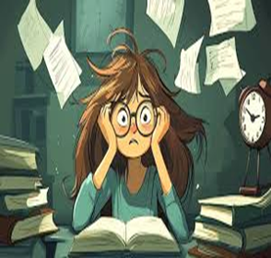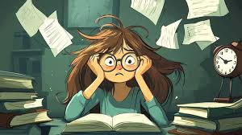

Digital Closeness, Human Distance
Technology, the most versatile word of the modern generation. Houses, buildings, offices, schools and many other important civil services use and take help of modern technology. Technology seems to be a sector of rapid growth with seemingly no stop to its extent and reach.
Ever since the birth of technology of machinery and electronic devices, all the way back in the early 1940s, there arose the controversy of the effects of technology upon human consciousness and standards. Man had always hoped to advance and evolve, so the invention the technology served as a stepping stone into the new era of Utopia.
Technology, as we know it today has advanced beyond an average human understanding capability. You ask a man how can I complete several assignments at once, and he will show you several multitasking facilities. If you ask him does multitasking on a device keep up with real time data or how do servers manage the web where people have access to the application internationally, he will be left with a blank face.
The use of social media also affects people adversely, especially youngster or teenagers and even small children. They very often compare the real life with someone else’s media-life, making them set unhealthy standards for life. This may cause arrogance and ignorance for others feelings and on the whole, make them feel lonely.
Technology is also the leading cause of depression and anxiety according to many recent studies and is advised not be a major part of one’s life. Technology today can be really dangerous as it makes one lonely, due to lack of control on priorities in one's life.
L Roshan Abraham
XI - MPC

A Taste of Rains in Our City
People in cities and urban areas rarely have a liking for rains. This happens only because people in cities miss out on holiday trips, vehicle damages, pathetic roads and the humidity to add to it all. The roads and drainage system in cities, especially during the monsoon, is at its worst compared to villages where the mud roads and the green cover soaks in the rain water.
Rain is a boon in rural areas for the cultivation of crops and their survival. Even in cities, rain provides great relief from the sweltering heat and helps in the rise of ground water level, thereby increasing the water supply in the city. As the saying goes, ‘Too much is too bad,’ heavy torrential rains affect the lives of the people.
According to various reports over the years, a majority of farmers and their families have ended their lives not because of no rains but because of excess rain and its adverse effects on their crops – flooding, damaged crops and suicides. In the city, it is no different, inundated streets, damaged vehicles, water entering houses and buildings, overflowing manholes and a standstill to life namely closure of educational institutions and frequent and long power cuts.
The continuous rains in our city in the months of August and September disrupted normal life for days together. It was only when the sun showed up after a long spell of wet days that we were happy but this happiness did not last long. The rain would usually start as a drizzle just when it is time for school to get over around three – three thirty and within a matter of minutes this drizzle would turn into a down pour.
Traffic jams, clogged manholes, flowing water and honking vehicles became a common sight every evening as school got over. Added to all this, several trees fell and blocked roads holding up the traffic for hours till some good souls came together to move it to the side and monitor the traffic. Our city witnessed one of the worst monsoons in decades this year which had a few positives but also caused numerous problems for the people.

S. Aditya
XII - AMEC


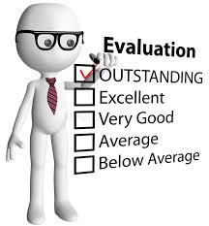

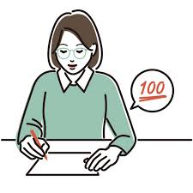

Should Students Be Allowed to Grade Their Teachers?
There is no school which does not evaluate its students. This is done to know how much the student has grasped and whether he is able to apply what he has learnt practically. In the same way, it is of paramount importance to assess a teacher’s skills from time to time.
This improves the teacher’s skillset. If the teacher writes an examination in the same way a student does, then he/she can put him/herself in the student’s shoes and realize where student needs to be strengthened. A student has to learn a concept well to write well in the examination. But this is not the case for a teacher, as she is already thorough with it. Hence, during this process, the teacher might discover many breakthroughs on how a student can write what he has learnt better, using tips and tricks shared by the teacher.
Secondly, it brings a change. A teacher if given a problem to teach for many students throughout the years, she would still teach it the same way as she did it the first time. But due to assessments, she realizes the students’ Achilles’ heel and transforms it into their strengths. It also helps the teacher to enable the students to look at the same problem from different perspectives, which helps them when attempting questions in the examination.
It also brings an understanding in the teacher. A teacher is only as good as his/her students. At times the problem does not lie in the students but in the teacher. This happens rarely, but if not addressed it can be catastrophic. Pointing to a teacher’s mistakes can be demeaning but is actually necessary because it affects the lives of the students.
Lastly, evaluation of teachers is a must to eradicate narrow-mindedness. If a teacher while correcting the answer papers of the students notices that the answers to the same question are different but it means the same, if the teacher goes by the answer given by him/her or which is in the textbook, then many students lose marks which is not morally right. The teacher must realize that each one in unique and must be allowed to write as their mind sees the question and understands it. A teacher must not look for the exact answer but for the most appropriate answer which has the key words and fulfils the criteria asked in the question.
To conclude, checking the aptitude of the teacher is highly advisable as it allows both teachers and students to be efficient, accurate and to have clarity. This also establishes better standard of education by empowering the teachers thereby enriching the quality of education.

P. Mukesh Kumar
XII - MPC

Every Student’s Nightmare
Exam stress is an essential aspect to talk about when it concerns students. It can be defined as the amount of stress and anxiety a student has to endure and which makes him pessimistic, depressed and overburdened.
We observe that only a handful of students or even less keep their calm during examinations. However, it is not the same for most students. They are stressed by the amount of syllabus they have to cover or try to ace in a subject they know nothing about. Studies show that exam stress has detrimental effects on students, both physically and psychologically.
Exam stress originates mainly from the fear of a particular subject or the teacher, competition with peers, pressure from parents to score good marks or your performance in the previous tests/examinations.
I believe that change is the spice of life but change can also be the key to efficiency and progress. There are many ways to drive away exam stress. Some of the most effective ways are: -
- To use Eisenhower Matrix: Studies show that seventy eight percent of students who followed this have succeeded in their examinations. Eisenhower Matrix is a kind of tabular form in a page divided into four parts – What needs to be done immediately, (Do First) What has to be done sooner or later, (Schedule) What has to be done after a long period of time from now (Delegate) and what can be neglected (Delete/Don’t Do). This method really helps you in reminding and reinstating your priorities in the form of a routine.
- The Two Minute Rule: In a survey, it was found that eighty-six percent of students really found this trick helpful in their lives. It is quite simple – when you are given a task, depending upon its complexity use a time – constraint, a deadline by which you have to complete the task. This not only helps you organize your tasks on the basis of their complexity but also inculcates discipline and keeps you on your toes all the time.
- Other methods include making a time table which you would have to follow everyday – studying for twenty-five minutes and taking a break for a couple of minutes, regular practice, revising the given syllabus.
It is better to start late than to never start. So, you can start with these tips to help you get rid of exam stress. From my experience, I would like to share a helpful tip – feel free to share your burden with your parents, teachers, elders, friends or anyone who can really relate and understand you because sharing your worries lessens your pain and relaxes your mind.

P. Mukesh Kumar
XII - MPC

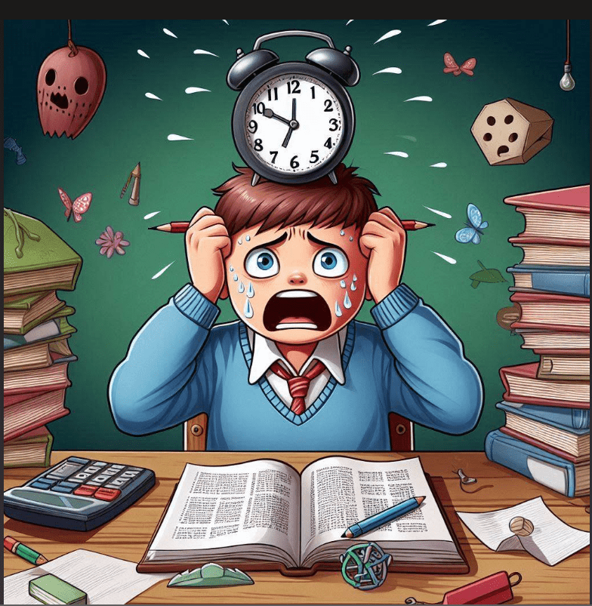
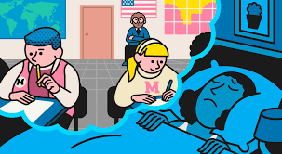
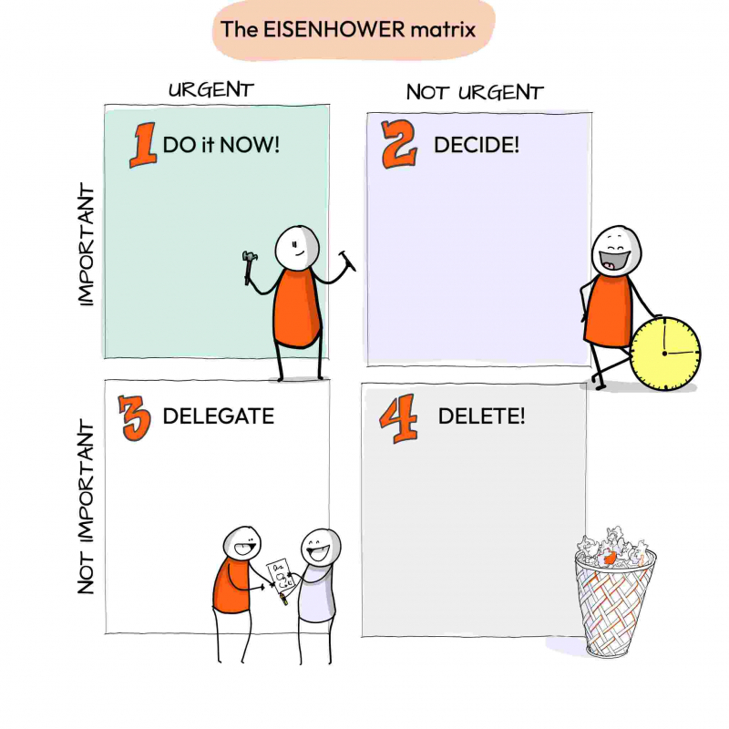




Does Technology Make Us More Alone? Are They Screens Between Us?
Let me begin by asking you to imagine the time during the Indian Independence Day in 1947. How was it then? Did they just send some reels on patriotism from a room in the house or did they stand united protesting the British? People then used to just pass time by gathering or playing together. How peaceful it was then? But now even in the remotest of villages we can find that peace without Technology.
Technology, the term which changed the society both optimistically and pessimistically. Though Technology has broadened the minds in certain aspects, it has also narrowed the way people interact. Go on the roads, you find people watching reels or updating their profile and what not. Go into someone’s house as a guest and they would not even bother about whether you have eaten or not. They just sit with their mobiles alone, one person in one room.
Coming to children, they may be around 2 or 3 years old, unable to even talk properly but they will have a phone or a tablet in their hands. This technology is just spoiling everybody. I do not even remember watching television during my childhood.
People most of them, would have watched the advertisement where a person is dragged by a phone does not even care for his own parents. but when he is finally out of technology, he repents but it is too late. Everybody must have watched this in real. Is there a change in any of them? No, they just share it with one another as a joke and ignore it.
Technology is making us alone. It is making everyone an introvert. The sooner people realise this, the better our lives would become. There is no mention that technology should not be used but we must use it wisely. It should be us be who should control technology and all its allies and not us who should be controlled by it.
In conclusion, technology is making us alone. The world knows and understands this but still it ignores it. We should not be following Technology for its negative impacts as people are losing their confidence and the habit of talking by spending time alone with technology.
S Aditya
XII - AMEC

The Loneliness Machine
“I would choose him over you any day.” said Natalie. He can be anything and everything to me forever and ever, Josh.”
It was the late 2100’s, Natalie, a bright inventor lived with the husband Josh. she also had a son named Augustine. Everyday Josh would drop Augustine to school on the way to his workplace. They were a satisfied family who were bound together until one day, a dark black minivan hit a group of boys who were crossing the road.
Few were injured but Augustine and another boy died on the spot. Josh cried for days and then understood the painful reality. However, Natalie could not handle the loss of her only child. she cried and cried for days and then became silent and emotionally unresponsive as days passed.
Two years passed, a gap created between Josh and Natalie, which was unbearable for both of them. Josh tried to help her but as time passed, she distanced herself from the outside world and eventually Josh. She would be there all day in her basement where she would work for hours together with unwavering focus. And after a lot of trials and errors she created an auto responsive Zeta intellectual humanoid or as she would call it, Azimuth. Now, Azimuth meant the world to her. it would do the work of six people at once. Josh did not like the fact that Natalie had replaced Augustine with Azimuth.
He tried his best but in vain. She said that she would replace him too with another bot which was already in the making, named John. Josh too left her in the house and went far away.
Many years had passed and one day when it rained, it caused an electrical damage to all the electrical appliances in the city including John and Azimuth. There they stood like statues. Only then did Natalie realise the fact that she had replaced her son and her husband with robots. So, she chose her creations over humanity making her lonely even when among her own creations.
P Mukesh Kumar
XII MPC

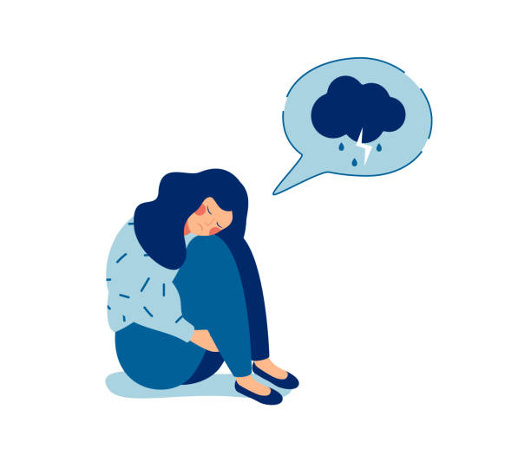
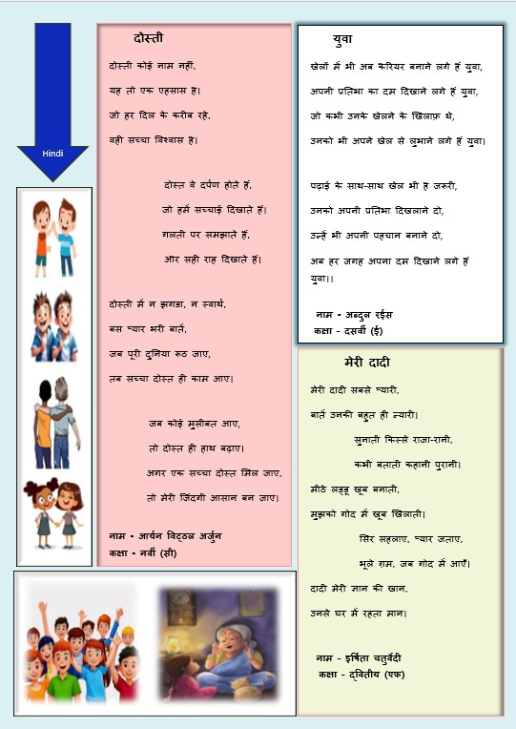

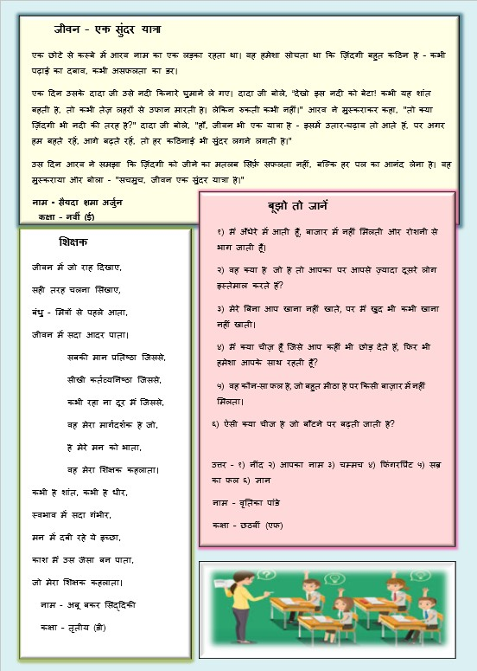

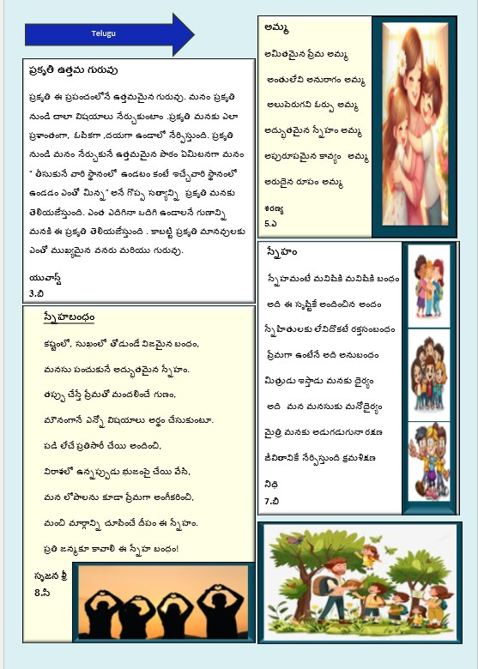

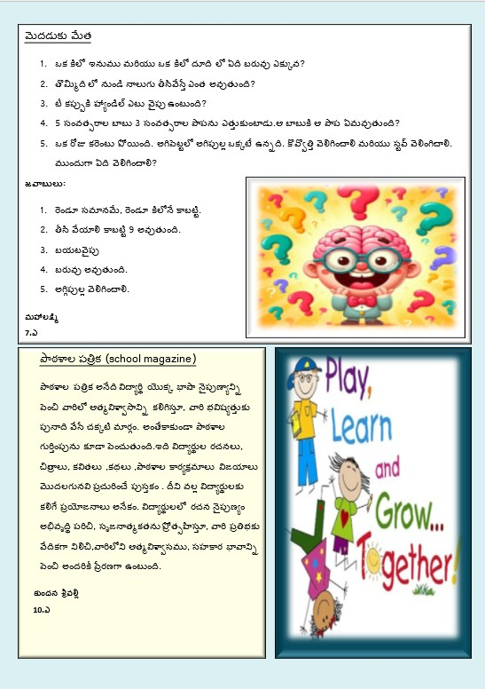

“From classrooms to corridors, there’s always something happening—teachers and students learning, creating, and celebrating together.”
“So many activities unfolding—I’ll step in and be part of the story!”

“Log in to our school website to learn more about our journey. Admissions are now open—come be part of our community of hope, courage, and new beginnings.”

Events 2025
- A Day of Prayer (Staff)
- Professional Development Programme
- Cyber Security
- Stress Management
- Presentation of Answer Sheets
- School Reopening
- Holy Spirit Mass
- Inter House Activities (Various Clubs)
- Inter School Activities (Various Categories; Literary/Sports/Cultural)
- NCC Activities
- Good Samaritan Day
- Stress Management and Slow Learners

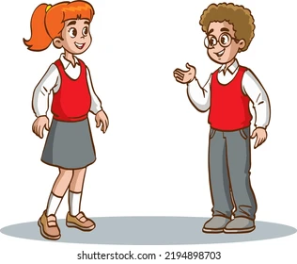

https://www.stpatrickshighschool.ac.in/

